Andong Yan

4/28/2017

Prof. Jeff Nugent

Econ 541: Term Paper

What Keeps Countries from Capital Account Liberalization? The Case of China

1. **Introduction**

Peter Blair Henry (2000) states that “stock market liberalization may reduce the liberalizing country’s cost of equity capital”, and he further points out that such prediction has two implications: first is people should observe “an increase in a country’s equity price index”, and second is “an increase in physical investment following a stock market liberations”. From a policymaker’s point of view, these two implications are attractive features for a state since, theoretically, more physical investment should result in a higher economics output equilibrium, and the increasing equity price index is usually referred to a phenomenon of the economy boom in common sense.

Despite the promising advantages of stock market liberalization, almost forty years have passed since its successful economic reform at 1978, the Chinese government has not fully lifted its restrict on capital accounts yet. In fact, according to IMF’s Annual Report on Exchange Arrangements and Exchange Restrictions (AERARE) and many indexes which measures financial openness (e.g. Chinn-lto index), China is currently is one of the countries which have the most restricted capital control in the world. Although there is news reporting that China’s government leaders are planning to dismantle all the capital controls before 2020 (*Bloomberg News*), it is interesting to discuss why the Chinese government is reluctant to implement a complete capital account liberalization for the past period and what potential outcomes could be if such a liberalization is realized. In this paper, I try to build up the link between capital account liberalization and economic growth, which is one of the main goals of government, and analyze whether the growth promised by economic theories could happen after the liberalization in China’s capital accounts. I adopt an index lately published by Chen and Qian (2016) to measure the intensity of China’s capital account control and find that there is a positive correlation between China’s economic growth and finance openness, but its significance varies as contexts change. I also check whether the channel of such positive effect is the investment boom caused by the gradual liberalization of capital account and the result supports the hypothesis.

The paper is organized into five sections. Section II reviews previous literature about the relationship between capital liberalization and economic growth. Section III introduces the status quo of China’s financial openness and compares China’s situation with other emerging markets. Section IV shows the empirical evidence about whether capital liberalization brought economic growth as well as investment boom. Section V concludes the paper.

1. **Literature Review**

Before further analyze whether capital account liberalization has an effect on economy growth, it is better to clarify first how stock market liberalization can result in an investment boom. Peter Henry (2000a) completes a comprehensive research, both theoretically and empirically, on how stock market liberalization correlates to investment growth and here I briefly summarize his work. A country’s cost of equity capital consists of the equity premium[1] and the risk-free rate. The stock market liberalization could increase net capital inflows thus reduce the risk-free rate; it also increases risk sharing between domestic and foreign investors, thus reduces the equity premium. Besides, a possible positive effect on market liquidity by increased capital inflows can reduce equity premium as well. With all these effects, the country’s cost of capital falls and temporary increase in investment growth appears until the marginal product of capital falls to the same level of the new cost of capital. Meanwhile, the discounting rate used in evaluating equity shares also decreases due to decreased risk-free rate and equity premium, thus a revaluation of stock shares with higher prices is expected to be accompanied with the increase in investment growth after the stock market liberalization.

Henry (2000a) conducts from a sample of 11 emerging capital markets that stock market liberalizations lead private investment boom. Many developing countries liberalized their stock markets in the late 1980s and early 1990s, and from 11 selected markets, their mean growth rate of private investment jumped high by 22 percentage points, and most of them remained an abnormal higher growth rate of private investment in the following three years after liberalization. In another paper, Peter Henry (2000b) also argues with the data from a similar sample of countries that, after controlling for many economic factors, stock markets experience average abnormal returns of 3.3 percent per month in real dollar terms during an eight-month event window following the country’s initial stock market liberalization. Other literature, such as Kim and Singal (2000) and Patro and Wald (2005), find similar results as Henry (2000) does.

However, many literatures (Rodrik, 1998; Eichengreen 2001; Edison et al., 2004; Prasad et al., 2003) argue that according to empirical analysis, there is no correlation between the capital account liberalization and investment growth, economy growth or any economics variables with welfare implications. They conclude that capital account liberalization, at best, has only an ambiguous effect on economy growth. Prasad et al. (2003) in a survey of capital account liberalization research also conclude that “…an objective reading of the vast research effort to date suggests that there is no strong, robust, and uniform support for the theoretical argument that financial globalization per se delivers a higher rate of economic growth.” According to the neoclassical economics model, a capital account liberalization results in more allocative efficiency, as capital flows from developed countries to developing countries and the cost of capital should decrease in the liberalizing countries. With this effect, more investment projects should become profitable due to the fewer cost of investment, thus investment growth increase and push up the economy output. The two opposite views raise the question that since there are many other distortions to the economy other than barriers to free capital flows as the case of many LCDs in the real world, does the theory-promising increase in investment brought by the capital account liberalization still exist?

While it is not safe to conclude that the capital market liberalization can bring countries higher investment growth rate, Henry (2007) demonstrates that the neoclassical model only predicts temporary increase in the growth rate, not permanent, while “the cross-sectional regressions done in the previous literature could only look for permanent effects on differences in long-run growth rates across countries”. In other words, the empirical testing for a permanent growth effect cannot exclude the possibility that liberalization affects the investment growth temporarily after the event. By empirical analysis using the time-series data, a positive correlation between investment growth and stock market liberalization is robust after controlling country-specific economics factors, world business cycle effects, etc. With these results, the Chinese government should feel more confident to implement further stock market liberalization policies, such as an expansion on the quota of QFII or allowing direct participation from foreign investors.

1. **China Capital Account Openness Status Quo**

In the late 1980s and early 1990s, many emerging market countries started the process of opening their domestic financial markets. During that period, Asia attracted almost half of the total capital inflow into developing countries. Many southeast Asia countries maintained high interest rates attractive to foreign investors and received a large inflow of money and experienced a dramatic run-up in asset prices. With the boom of foreign investment, these countries experienced high growth rate around 8-12% GDP. Meanwhile, China experienced a phenomenal high growth rate of the economy without significant capital account liberalization during the latter period. By May 2015, China’s stock market was worth over $10 trillion, around a quarter of world market cap; in contrast of the huge capital volume, several policies like Qualified Foreign Institutional Investor (QFII) Scheme and RMB Qualified Foreign Institutional Investor (RQFII) Scheme only relieved the restraints on foreign capital investment in China’s domestic stock markets, but a complete market capital liberalization is absent.

In fact, China’s stock market was mostly segmented from the global capital market (B share market is exclusive for foreign investors, but only 24 companies were listed) till November 5, 2002, when China regulatory announced the QFII scheme. While this is the most important stock market liberalization policy enforced by China, QFII did not fully open the door to foreign capitals to participate in China’s stock market, as current QFII quota is $10 billion, less than 2 percent of Chinese stock market shares. China’s stock market is still insulated from the world market, and apparently, there are more liberalization policies that government can implement to fully open the stock market. Besides, China’s control of capital outflow remains restricted currently, as from personal experiences, individuals in China can exchange RMB for U.S. dollars with an annual quota of $50,000. While it is surprising that China owns such a huge stock market without many activities of global capitals, the reasons why Chinese government implemented a tight policy towards capital inflows and outflows are important from an economist’s aspect.

Many potential answers may explain why China’s government keeps its regulation: first, government regulates the inflow and outflow capitals strictly due to its desire for a stable economy environment, which could be affected by the large volatility in foreign investment. On one hand, the government cannot allow a huge amount of foreign capital inflow that brings an appreciation in RMB and deteriorates the term of trade. On the other hand, capital outflows could increase tremendously when people’s expectation of economics growth goes down and thus a capital flight, which is more dangerous than the currency appreciation, may happen. Due to Mundellian Trilemma, the government must sacrifice the capital mobility to ensures a stable exchange rate as well as an independent monetary policy. When looking into the history, there were also lessons from the financial crisis due to sudden financial openness and unprepared domestic financial institutions. Table 1 presents the financial crisis happened during 1980-1990s.

|  |  |  |  |
| --- | --- | --- | --- |
| Table 1: Capital Liberalization and Financial Crisis | | | |
| Country (Year of Financial Crisis) | Short-term international capital movements | Long-term international capital movements | crisis occurs within 5 years of liberalization |
| Argentina (1980) | Open | Open | Yes |
| Argentina (1989) | Close | Close | n.a. |
| Argentina (1995) | Open | Open | Yes |
| Chile (1981) | Open | Open | Yes |
| Mexico (1994) | Open | Open | Yes |
| Venezuela (1994) | Close | Open | n.a. |
| Malaysia (1985) | Open | Open | No |
| Philippine (1981) | Close | Open | No |
| Thailand (1997) | Open | Open | Yes |
| South Africa (1985) | Close | Open | No |
| Turkey (1985) | Open | Close | No |
| Turkey (1991) | Open | Open | Yes |
| United States (1980) | Open | Open | No |
| Canada (1983) | Open | Open | No |
| Japan (1992) | Open | Open | No |
| France (1991) | Open | Open | Yes |
| Italy (1990) | Open | Open | Yes |
| Australia (1989) | Open | Open | Yes |
| New Zealand (1989) | Open | Open | Yes |
| Brazil (1994) | Close | Close | n.a. |
| Indonesia (1992) | Open | Open | No |
| Korea (mid-1980s) | Close | Open | Yes |
| Turkey (1994) | Open | Open | Yes |
| Sri Lanka (mid-1990s) | Close | Open | Yes |
| Citation: 陶然. 金融稳定目标下的资本账户开放研究. 中国财政经济出版社, 2009. (Only Chinese edition available) | | | |

One notifiable fact is that most of the countries experienced a financial crisis in a window of 5 years after their capital account liberalizations. Eichengreen and Bordo (2002) investigates the frequency of financial crisis in 21 countries from 1980 to 1998 and points out that financial crisis happens more frequently in the era when capital account liberalization spread widely in global countries. However, Glick and Hutchison (2005) conduct empirical analysis on the relationship between capital account liberalization and currency rate instability with the sample of 160 currency crises during 1975-1997, and they conclude that countries with more restrict capital control have a higher chance to experience volatility in the currency rate. While research provides no clear evidence to state the causality between capital account liberalization and financial crisis, the stories of previous crisis warn Chinese policymakers that financial openness is not the panacea for economy growth.

Second, it is the economy fluctuation might stop the liberalization process. Back to 2015, there used to be news about a deeper liberalization would happen when Chinese stock market started its latest boom. Unfortunately, in June 2015, the stock market collapsed and the index fell from peak over 5000 points to almost half of it. The huge fluctuation prevented the policymakers implementing further liberalization but start to stabilize the stock market. Same story happened during the economy crisis of 2007-08, as a lately invented index that measures the intensity of China’s government’s control on capital account displays in the following graph:

In the y-axis, a positive number means stronger regulation on the capital transaction, thus the graph shows that from 2000-2014, China’s capital account is gradually open. However, the trend is reversed during the years between 2007-2009, when the global economy crisis occurred. The movement of the index partially proves the hypothesis that government restricted capital transactions to maintain economy stability when crises arose. In the following section, I further explain the details of this Hybrid index of China’s capital account openness.

Third, how much effect, if it is positive, could capital account liberalization bring to economy growth is questionable. Chen et al (2012) find that QFII did not work well in improving equity index pricing as the only significantly negative correlation between the stock market index and the announcement of QFII is found in the post-event period of 20 days. Much other research mentioned in the previous section also cast doubt on the effect of capital account liberalization could have on economy growth after controlling countries’ fundamental performances, business cycles, and many related factors.

These factors, especially the third one, might concern the Chinese policymakers and make them less confident to deeply liberalize the capital market. In the following section, I try to illustrate the channel between capital account liberalization and economy growth and explain why it might be better to open the stock market more for the Chinese government.

1. **Capital Account Liberalization and Economy Growth**

In this section, I conduct an empirical analysis of the relationship between capital account liberalization and economy growth as well as investment growth in the context of China during 2000-2014. When previous literature conducts similar research, they usually extract information from the text of IMF's Annual Report on Exchange Arrangements and Exchange Restrictions (AREAER)[2]. While AREAER covers most of global countries’ information about the openness of capital account, it only has limited information about whether there is regulation on capital transactions in one country, similar as “Yes or No”. As many researchers simply generate the binary data from this information, the measurement of China’s capital account openness becomes very vague under these indexes. For example, in the Chinn-Ito index[3], China’s score of capital account openness remains at a low level and has been unchanged since 1993. In another research, Fernández et al (2015) conduct a new index to measure restrictions on capital flows, but China’s score has a very small interval and has little variation over time. However, Kruger and Gurnain (2016) display the data of China’s gross capital inflow and outflow and show that the volume of capital flows increase over time, in pace with GDP. (following graph is cited from their paper)

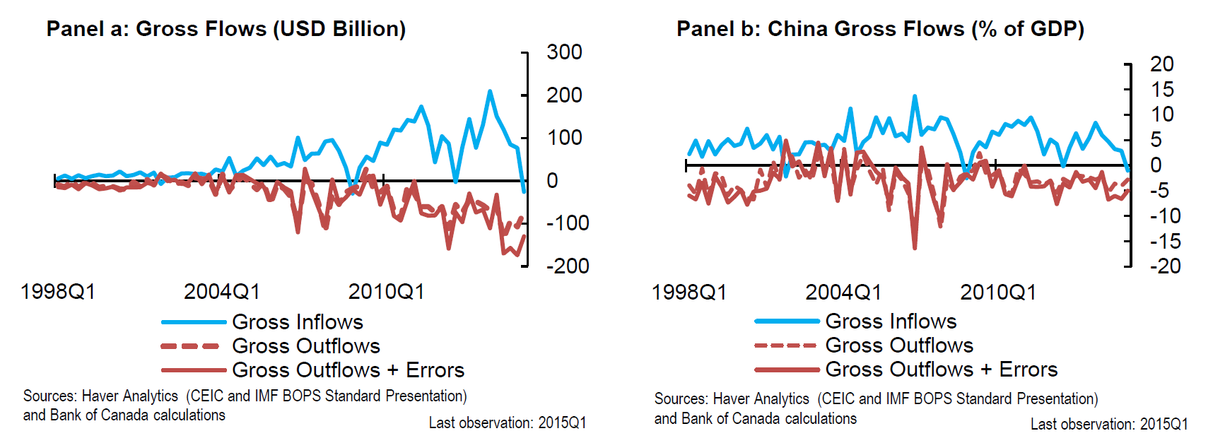

Such inconsistency between the *de jure* and *de facto* measurements on the China’s capital account openness raises the need for a new accurate measurement tool. This diversity is because China usually implements policies step by step in a gradual style, and sometimes even step back for the reasons of stability. Each small ease of capital control is stated in the AREAER, but it cannot change the overall statement of China’s control of capital transaction in AREAER’s summary table. As a result, indexes that only extract information from the AREAER summary cannot reflect the change in China’s financial openness.

To handle the difficulty of measuring China’s capital account openness and facilitate new studies on China’s capital control and capital flows, Chen and Qian (2016) conduct a new index that incorporate detailed information about China’s capital control policies stated in the AREAER. To measure the intensity of capital control, they add a value of 1 to the existing score when a policy tightens controls on capital transaction, *vice versa*. Moreover, they calculate the weight that represents the importance of each sub-category under capital transaction, as the share of a subcategory asset value in the total value of all asset categories in China’s capital account. Finally, they calculate the weighted index which reflects the change in intensity of China’s capital control since 1999. In this way, this new hybrid index captures data from both *de jure* and *de facto* measurements and reflects the influence of a newly implemented policy on the overall capital account openness more accurately[4]. In my following paper, I use this hybrid index as my measurement of China’s capital account openness to finish my empirical analysis. Since this paper only discusses capital account liberalization in the context of China, there is no need to use other methods other than OLS to check the correlation between economy growth and capital account openness. Here is my OLS model:

$$\ln\left(y\right)=α+β*Capital+χ+ε$$

In the equation, *y* represents GDP; *Capital* represents openness of China’s capital account, which I use the hybrid index introduced previously to measure; $χ$ is the vector of other fundamental factors, including investment, labor force, expenditure on R&D and trade performance. All fundamental data are collected from World Bank Database and adjusted for inflation. I also include dummy variable for financial crisis of 2007-08 to check robustness of the result. Here, coefficient $β$ captures the effect of capital account openness on economy growth, and it should present negative value to reflect a push-up in economy growth since the hybrid index has a higher positive value when capital control tightens.

Table 2 displays the results from regression on *ln(invest), ln(trade), ln(R&D), ln(labor)* and *hka*, the hybrid index of China’s capital account. The coefficient of *hka* shows that an average capital control easing policy, weighted by the importance of the policy effective subcategories among all China’s capital transactions, should contribute to 0.03% China’s GDP growth and this effect is significant at 5% level. While coefficients of *ln(trade)* and *ln(R&D)* have the expected positive signs and are significant at 5% level and 1% level, respectively, it is odd that investment factor is not significant and the labor factor has a negative correlation with economy growth. Table 3 shows that although *hka* is negatively correlated to economy fundamental factors as the model predicts, the fundamental factors are highly correlated to each other. Table 4 includes a dummy variable for the financial crisis, and *hka* remains significant and the magnitude of the coefficient nearly changes.

One explanation for the unexpected result of investment and labor force factors is that the model is overfitting the data, especially in the case that there are only 15 observations but 5 or 6 independent variables. The relatively small sample exaggerates the multicollinearity issue of the highly endogenous independent variables so that their coefficients and significance could be meaningless in identifying the effect of one single factor on the economy.

Table 2



Table 3



Table 4



To check whether capital account openness factor generates significant effects independently to other factors, I conduct empirical analysis using *hka* as the independent variable, and combining it with another factor in turn to check the robustness of the previous results.

Table 5

|  |  |  |  |  |  |
| --- | --- | --- | --- | --- | --- |
| Independent variable | Dependent Variable: *ln (GDP)* | | | | |
| hka | -.7024637** | -.7141755** | -.0720953 | -.272907 | -.0299126** |
| crisis |  | Yes |  |  | Yes |
| trade |  |  | Yes |  | Yes |
| labor |  |  |  | Yes | Yes |
| R&D |  |  |  |  | Yes |
| invest |  |  |  |  | Yes |

** means significance at 5% level, “Yes” indicates that he variable is included in the regression.

It is easy to see from Table 5 that the coefficient of *hka* remains negative but varies dramatically as the another explaining variable turns, and its significance also disappears when trade and labor factors join the regression. R&D and invest factors are not included because their explaining power of GDP is too strong (R-square approaches 1) that any other correlated variable could have a biased coefficient in the regression. Table 5 suggests that the effect of capital account liberalization on economy growth is not perfectly revealed, however, if there is a significant one, capital account liberalization should improve the growth of the economy.

After analyzing the relation between capital account liberalization and economy growth, it is important to explore the channel of the openness improving the economy effect. Recall that the stock market liberalization could reduce both risk-free rate and equity premium by increasing net capital inflow and reducing the risk of equity. Potential increasing liquidity followed by foreign capital inflow could reduce equity premium as well. With all these effects, the country’s cost of capital falls and temporary increase in investment growth appears. Besides, discounting rate used in evaluating equity shares also decreases due to decreased risk-free rate and equity premium, thus equity **price should be revalued at a higher price level as well as an increase in investment growth occurs after the stock market liberalization.**

What needs to notice is that the theory of decreased cost of capital has an implicit assumption, that is a country’s risk-free rate falls after the stock market liberalization. But this condition may be violated when the capital inflows are overwhelmed by a huge capital outflow by domestic residents, or the autarky risk-free rate is already lower than the world rate. In the case of China’s stock market, such concerns are unnecessary. Although some research (Collins and Bosworth, 1996; Young, 1995; Kim and Lau, 1994) show many emerging Asian countries have had very high saving rates which may drive down the interest rate, comparing the risk-free rate of China’s money market to other major currency markets should conclude that China has a relatively high interest rate, thus a higher cost of capital than the level of world market. As a result, as far as China’s government keeps its regulation on capital outflows and keeps liberalizing the stock market, it is expected to see a temporary increase in investment growth and a permanent increase in GDP per capita.

I run an OLS regression of investment on the hybrid index of capital account openness and the result shows that a unit increase in the hybrid index can increase investment by 8% significantly. However, due to multicollinearity issues within fundamental factors, it is improper to include all fundamental factors into the regression to analyze the effect of capital account liberalization on investment because the coefficients could be unidentifiable. Instead of focusing on investment growth, I turned to the other theory-predicted phenomenon – revaluation in the stock market. According to the theoretical model, since the discount rate decreases, asset prices should increase following the capital control easing policy.

Table 6

|  |  |  |  |  |  |  |
| --- | --- | --- | --- | --- | --- | --- |
| Panel a. Regression of stock index on hybrid index | | | | | | |
| stockindex | Coef. | Std. Err. | t | P>t | [95% Conf. Interval] | |
| hka | -0.0610561 | 0.0297499 | -2.05 | 0.042 | -0.1197641 | -0.0023481 |
| _cons | 0.7196732 | 0.0387049 | 18.59 | 0 | 0.6432937 | 0.7960528 |
| Panel b. Regression of stock index growth on difference in hybrid index and lagged level | | | | | | |
| diff_stock~x | Coef. | Std. Err. | t | P>t | [95% Conf. Interval] | |
| diff_hka | -0.050513 | 0.0468172 | -1.08 | 0.282 | -0.1429047 | 0.0418787 |
| hka_01 | -0.0043304 | 0.0066259 | -0.65 | 0.514 | -0.0174062 | 0.0087455 |
| _cons | -0.002471 | 0.0082058 | -0.3 | 0.764 | -0.0186648 | 0.0137228 |
| Panel c. Data Statistics of China's Stock Index | | | | | | |
| Variable | Obs | Mean | Max | Min | Std. Dev. | |
| stockindex | 180 | 0.7839778 | 2.037 | 0.368 | 0.3075822 | |

Table 6 shows results from the regression of China’s stock index on hybrid index of capital account openness. The data used here is monthly based instead of annually aggregate data that I used in the previous empirical analysis. The only difference in the hybrid index is that I calculate the annual data of hybrid index by taking the average of 12 months in one year. The stock index is the index of “Total Share Prices for All Shares for China” cited from Federal Reserve Bank of St. Louis website. In Panel a, where a simple OLS coefficient represents that an average capital control easing policy can increase the stock index by 0.06 significantly. However, when I use the difference in hybrid index and its lagged level as the independent variables to measure their effects on China’s stock market, the significance disappears as shown in Panel b although their coefficients have desired negative signs.

One possible explanation is that China’s government has a strong motivation to maintain stock market’s stability. Depending on this hypothesis, a potential scenario could be that China implements easing capital control policies when the stock market is low while tightening capital control policies when stock market appears to be too “hot”. As a result, while capital account liberalization still has a significant effect on stock market performance, the change in the hybrid index brought by specific policies could have no effect on the short-term stock market index due to the cherry-picking on the timing of policy announcements. Another possibility could be that the data sample misses the China’s A share big bull during late 2015. The hybrid index data is only available through 2014, and the index shows that China’s capital account had an opening trend at that time. If the data can cover the bull market, the result could better reflect the correlation between financial opening and stock market performance. Since results in Table 6 show that capital account liberalization does improve the stock market performance, it indicates that there is a revaluation of equity asset due to decreased discounting rate. In other words, capital account liberalization could decrease the cost of capital, thus bring more positive NPV investment projects as well as an increase in investment growth, which is also proved by my previous regression results.

1. **Conclusion**

In this paper, I analyze whether capital account liberalization could cause economy growth in the specific context of China. Due to the gradual style in implementing policies, it is more complicated to measure China’s financial openness situation. To measure the intensity of capital account liberalization, I adopt a newly invented hybrid index which incorporates both *de jure* and *de facto* measurements based on information from IMF’s AERARE and China’s capital transaction composition. Depending on the hybrid index and theoretical models developed in the previous literature, I conduct empirical analysis on the capital account liberalization as well as investment growth. I find that it is unclear whether capital account liberalization has a significant effect on economy growth, but I conclude that the direction of such an effect should be positive for the economy. Due to lack of a broad database, my conclusion on capital account liberalization could cause investment boom is limited; on the other hand, I am able to show the capital account opening process contributes to a better stock market performance, which suggests financial openness could decrease the cost of capital and increase investment growth. As Peter (1999) also admits that government could choose to implement the stock market liberalization policy foreseeing the increasing investment growth and the causality between liberalization and growth are still unknown, it is crucial to investigate more on what are the main factors of the investment growth.

**References**

Arteta, Carlos, Barry Eichengreen, and Charles Wyplosz. *When does capital account liberalization help more than it hurts?*. No. w8414. National bureau of economic research, 2001.

Chen, Chun-Da, Chih-Chun Chen, and Chiao-Ming Cheng. "Impacts of the Stock Market Liberalization in China: Evidence from the Foreign Institutional Investor Scheme." *SSRN Electronic Journal* (2012): n. pag.

Chen, Jinzhao, and Xingwang Qian. "Measuring on-going changes in China's capital controls: A de jure and a hybrid index data set." *China Economic Review* 38 (2016): 167-182.

"China Plans 2020 Deadline for Dismantling Capital Controls." *Bloomberg.com*. Bloomberg, 22 Oct. 2015. Web. 28 Apr. 2017.

Collins, Susan M., Barry P. Bosworth, and Dani Rodrik. "Economic growth in East Asia: Accumulation versus assimilation." *Brookings papers on economic activity* 1996.2 (1996): 135-203.

Edison, Hali J., et al. "International financial integration and economic growth." *Journal of international money and finance* 21.6 (2002): 749-776.

Eichengreen, Barry, and Michael D. Bordo. *Crises now and then: What lessons from the last era of financial globalization*. No. w8716. National Bureau of Economic Research, 2002.

Glick, Reuven, and Michael Hutchison. "Capital controls and exchange rate instability in developing economies." *Journal of International Money and Finance* 24.3 (2005): 387-412.

Glick, Reuven, Xueyan Guo, and Michael Hutchison. "Currency crises, capital-account liberalization, and selection bias." *The Review of Economics and Statistics* 88.4 (2006): 698-714.

Henry, Peter Blair. "Capital account liberalization: Theory, evidence, and speculation." *Journal of Economic Literature* 45.4 (2007): 887-935.

Henry, Peter Blair. a. "Do stock market liberalizations cause investment booms?" *Journal of Financial Economics* 58.1-2 (2000): 301-34.

Henry, Peter Blair. b. "Stock market liberalization, economic reform, and emerging market equity prices." *The Journal of Finance* 55.2 (2000): 529-564.

Kim, E. Han, and Vijay Singal. "Stock Market Openings: Experience of Emerging Economies." *The Journal of Business* 73.1 (2000): 25-66.

Kim, Jong-Il, and Lawrence J. Lau. "The sources of economic growth of the East Asian newly industrialized countries." *Journal of the Japanese and International Economies* 8.3 (1994): 235-271.

Kruger, Mark, and Gurnain Pasricha. *What to Expect When China Liberalizes Its Capital Account*. No. 16-10. 2016.

Minsky, Hyman P. "The financial instability hypothesis: an interpretation of Keynes and an alternative to “standard” theory." *Challenge* 20.1 (1977): 20-27.

Patro, Dilip K., and John K. Wald. "Firm characteristics and the impact of emerging market liberalizations." *Journal of Banking & Finance* 29.7 (2005): 1671-695. Web.

Prasad, Eswar, Kenneth Rogoff, Shang-Jin Wei, and M.Ayhan Kose. "Effects on Financial Globalization on Developing Countries: Some Empirical Evidence." *INTERNATIONAL MONETARY FUND* (2003): n. pag.

Rodrik, Dani. "Who needs capital-account convertibility?" *Essays in internaitional finance* (1998): 55-65.

Young, Alwyn. "The tyranny of numbers: confronting the statistical realities of the East Asian growth experience." *The Quarterly Journal of Economics* 110.3 (1995): 641-680.

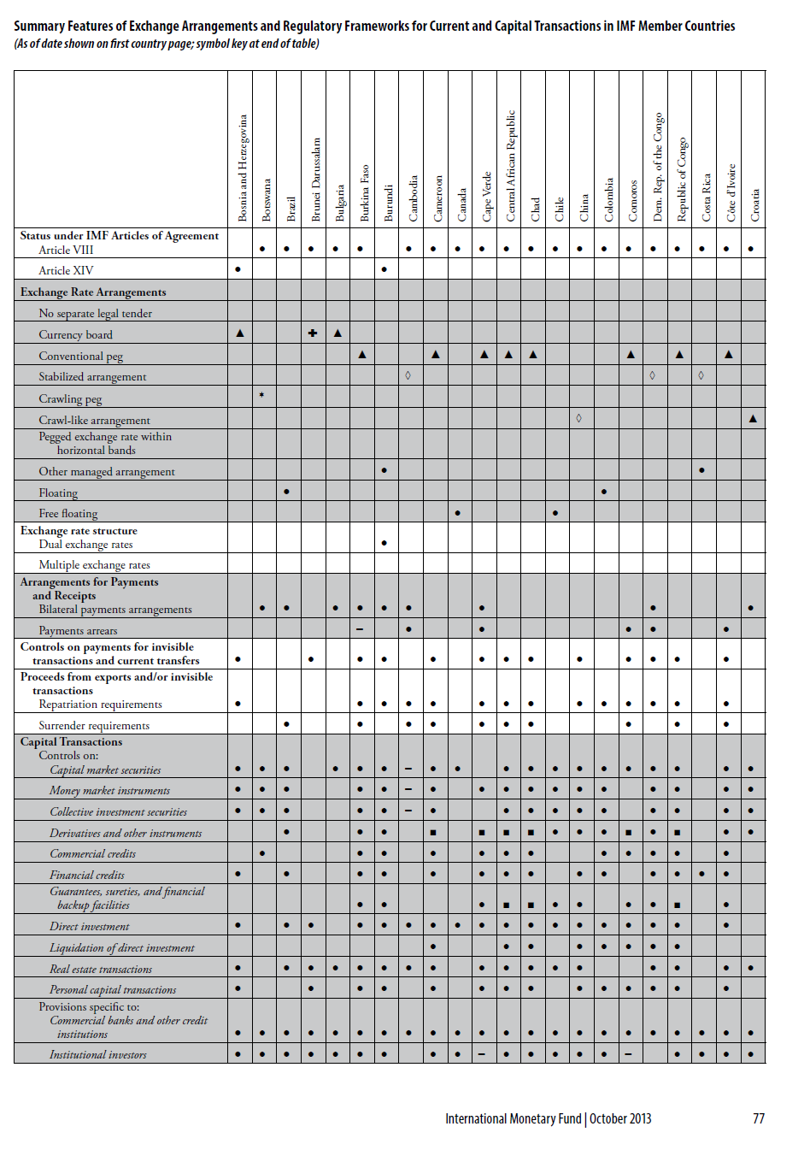Appendix A

Appendix B

|  |  |  |  |  |  |
| --- | --- | --- | --- | --- | --- |
| Year | Chinn-Ito Index | | Fernández et al Index | | |
| 1993 | -1.188757 | 0.1648092 | N/A | N/A | N/A |
| 1994 | -1.188757 | 0.1648092 | N/A | N/A | N/A |
| 1995 | -1.188757 | 0.1648092 | 1 | 1 | 1 |
| 1996 | -1.188757 | 0.1648092 | 1 | 1 | 1 |
| 1997 | -1.188757 | 0.1648092 | 0.95 | 0.9 | 1 |
| 1998 | -1.188757 | 0.1648092 | 0.88 | 0.9 | 0.85 |
| 1999 | -1.188757 | 0.1648092 | 0.87 | 0.9 | 0.83 |
| 2000 | -1.188757 | 0.1648092 | 0.95 | 1 | 0.9 |
| 2001 | -1.188757 | 0.1648092 | 1 | 1 | 1 |
| 2002 | -1.188757 | 0.1648092 | 1 | 1 | 1 |
| 2003 | -1.188757 | 0.1648092 | 1 | 1 | 1 |
| 2004 | -1.188757 | 0.1648092 | 1 | 1 | 1 |
| 2005 | -1.188757 | 0.1648092 | 1 | 1 | 1 |
| 2006 | -1.188757 | 0.1648092 | 1 | 1 | 1 |
| 2007 | -1.188757 | 0.1648092 | 1 | 1 | 1 |
| 2008 | -1.188757 | 0.1648092 | 1 | 1 | 1 |
| 2009 | -1.188757 | 0.1648092 | 1 | 1 | 1 |
| 2010 | -1.188757 | 0.1648092 | 1 | 1 | 1 |
| 2011 | -1.188757 | 0.1648092 | 1 | 1 | 1 |
| 2012 | -1.188757 | 0.1648092 | 1 | 1 | 1 |
| 2013 | -1.188757 | 0.1648092 | 0.9 | 0.9 | 0.9 |
| 2014 | -1.188757 | 0.1648092 | N/A | N/A | N/A |
| In Chinn-Ito index, the lower, the opener capital account. In Fernández et al Index, the higher, the strong regulation on capital transanction. | | | | | |
|

Appendix C

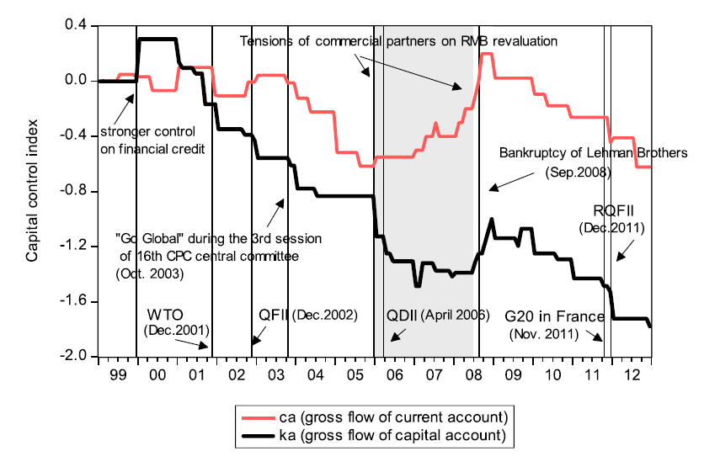

1. Equity premium, also referred to as equity risk premium, is the excess return that investing in the stock market provides over a risk-free rate. This excess return compensates investors for taking on the relatively higher risk of equity investing. The size of the premium will vary depending on the level of risk in a particular portfolio and will also change over time as market risk fluctuates.
2. An example could see at Appendix A.
3. See Appendix B.
4. Graph illustration shows more details about the hybrid capital control index.